**VDA Clean Diesel Website**

Copy Deck

**Landing Page:**

**Clean Diesel. Clearly Better.**

This is not your grandfather’s diesel. No way. Clean Diesel technology has changed everything. From the pump to the engine, it’s remarkably improved the driving experience. Say good-bye to loud trips with dirtier exhaust. And hello to great MPG, powered with exhilarating performance.

**MPGs:**

**More MPG. Fewer stops at the pump.**

Clean Diesel partner vehicles are on average 18% more fuel-efficient on the highway than their gasoline counterparts. And with over one-third of Clean Diesel partner vehicles getting an EPA-estimated 42 MPG hwy, you’re not only driving longer, but stopping less.

**Can you go up to 795 miles on one tank? (left)**

Let’s do the math. As an example, some Clean Diesel vehicles offer an EPA-estimated 43 MPG hwy under optimal driving conditions. For some vehicles with an 18.5 gallon tank, it might be possible to go 795 miles on the highway without stopping to fill up. Set the sliders below at how many miles you drive for each category during your daily commute. Then see an estimate of how many fewer times a year you may need to refill with some Clean Diesel vehicles.

*Fuel data based on sample automobiles, and does not necessarily reflect typical performance, which will vary based on the specific model you actually have. Gas results based on EPA-estimated 28 MPG hwy, 18.5-gallon tank. Diesel results based on EPA-estimated 43 MPG hwy, 18.5-gallon tank.*

**Look at the cost of fuel.**

**You might like what you see. (right)**

Here’s one specific example and an example only. The average person in the U.S. drives 13,476 miles annually. Your current gasoline car gets an EPA-estimated 28 MPG hwy. Some comparable Clean Diesel partner vehicles get an EPA-estimated 43 MPG hwy. It’s easy to see that it’s possible to save more annually on fuel. But just like the road of life, results may vary.

*Fuel data based on sample automobiles, and does not necessarily reflect typical performance, which will vary based on the specific model you actually have. Gas results based on EPA-estimated 28 MPG hwy, 18.5-gallon tank. Diesel results based on EPA-estimated 43 MPG hwy, 18.5-gallon tank.*

**Performance:**

**Powerfully quiet.**

When it comes to driving a Clean Diesel vehicle, torque is amazing. Quick acceleration and powerful handling are just what you’d expect from a sports car. But here is another surprise: Clean Diesel vehicles run much more quietly than those powered by their traditional diesel counterparts. Let’s just say, you’ve got to hear it to believe it.

**Don’t Sacrifice Power. (left)**

Whether passenger cars or SUVs, a 6-cylinder Clean Diesel engine is as powerful as a V-8 gasoline engine. Not to mention a Clean Diesel 6-cyinder engine is as fuel efficient as a 4-cylinder gasoline engine.

**Make an impact. Quietly. (right)**

When it comes to driving with Clean Diesel, you won’t believe how quiet your trip has become. Click or tap each speaker to hear an example of the difference between a Clean Diesel vehicle and another, older diesel.

**Environment:**

**A country with less smog.**

We used to think of diesel as black clouds of smoke and noxious fumes. But that was then. Now we have Clean Diesel that meets the highest standards in all 50 states, thanks to ultra-low sulfur diesel (ULSD) fuel and innovative engine technology that burns cleaner.

**1,400,000 barrels of oil. (left)**

If one-third of Americans switched to Clean Diesel vehicles, we would save approximately 1.4 million barrels of oil a day. In turn, we’d help reduce our carbon footprint by about 532 million pounds of CO2. And that’s like planting about 600,000 trees, every single day.

**Emotions run high.**

**Emissions, they stay low. (right)**

With Clean Diesel technology and ultra-low sulfur diesel fuel, we'll generate a lot less smog in the air. "Thanks," in advance, from the environment.

**Our Partners:**

**Clean Diesel and bright ideas are contagious.**

Starting with Audi, BMW, Bosch, Mercedes-Benz, Porsche and VW, Clean Diesel is gaining momentum worldwide with increasing development in all the major car manufacturers and others. Our partners include:

To learn more about the Audi TDI® Clean Diesel technology, [click here] <http://www.audiusa.com/us/brand/en/audi_tdi_clean_diesel_cars.html/>

To learn more about the BMW Advanced Diesel technology, [click here]

www.bmwusa.com/diesel

To learn more about Bosch technology, [click here]

[www.future-with-diesel.com](http://www.future-with-diesel.com)

To learn more about the Mercedes-Benz BlueTEC Clean Diesel technology, [click here] <http://www.mbusa.com/mercedes/benz/green/diesel_bluetec>

To learn more about the Porsche Clean Diesel technology, [click here]

<http://www.porscheusa.com/cleandiesel>

To learn more about the VW TDI® Clean Diesel technology, [click here]

http://www.vw.com/en/tdi.html

**Our Partners (mobile):**

Audi TDI® Clean Diesel

<http://www.audiusa.com/us/brand/en/audi_tdi_clean_diesel_cars.html/>

BMW Advanced Diesel

www.bmwusa.com/diesel

Bosch technology

[www.future-with-diesel.com](http://www.future-with-diesel.com)

Mercedes-Benz BlueTEC Clean Diesel

<http://www.mbusa.com/mercedes/benz/green/diesel_bluetec>

Porsche Clean Diesel

<http://www.porscheusa.com/cleandiesel>

VW TDI® Clean Diesel

http://www.vw.com/en/tdi.html

**More Information:**

The term “Clean Diesel” refers to innovative diesel engine technology, as well as the latest diesel fuel for vehicles. In contrast to traditional diesel, Clean Diesel is superior, since both the new generation of engines and the fuel itself meet the strictest emission regulations in the U.S. (issued by the state of California). Clean Diesel fuel contains less than 15 parts per million of sulphur; our Clean Diesel partner vehicles deliver on average 18% higher fuel efficiency while reducing CO2 emissions when compared to corresponding gas models. Since Clean Diesel is not only cleaner but also more fuel-efficient, the new Clean Diesel vehicles are friendlier to both the environment and drivers’ wallets throughout the U.S.

**MPGs**

Our partner’s Clean Diesel vehicles are on average 18% more efficient than corresponding gasoline models. This means that even if diesel fuel costs slightly more than gasoline in the U.S., Clean Diesel vehicles manage more miles per gallon.

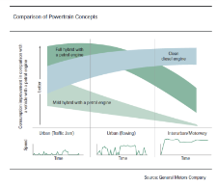

Clean Diesel power trains have a great operating range. For example, with a full tank it might be possible for a VW Passat Clean Diesel or a Porsche Cayenne Clean Diesel to travel over 700 miles on the highway.1

Our Clean Diesel partner engines demonstrate on average 18% higher fuel efficiency in comparison with their modern gas engine counterparts thus facilitating significantly larger ranges. This implies that the diesel engine makes a higher contribution to the achievement of fuel-economy objectives, which in turn leads to significantly fewer trips by the customer to the gas station.

Trips to the tank calculations.

For Diesel, the multiplier is 0.46 x Number Of Miles Traveled Per Day = Annual Trips Per Year

For Gas, the multiplier is 0.71 x Number Of Miles Traveled Per Day = Annual Trips Per Year

Diesel — One tank of clean diesel is based on the Volkswagen Passat TDI®. The Passat TDI® holds 18.5 gallons per tank, gets EPA-estimated 43 mpg on highways and therefore, under optimal conditions, may get 795 miles per tank on the highway.2

("z" miles per day X 365 days per year) / 795 gallons per tank (or trip) = 0.46z

Gas — One tank of gas is based on the Toyota Camry, which was the second-most-sold car in 2011 that was not a pickup truck.3The Camry holds 17 gallons per tank, gets an EPA-estimated 28 mpg on highways and therefore, under optimal conditions, may get 476 miles per tank.4 In order to have a fair comparison, the Diesel and Gas vehicles must hold the same gallons per tank, so for calculating purposes 18.5 gallons per tank will be used. With this, a Camry might be able to get 518 miles per tank on the highway.

("n" miles per day X 365 days per year) / 518 gallons per tank (or trip) = 0.71n

For more Diesel and Gas vehicle comparisons, visit <http://www.dieselforum.org/index.cfm?objectid=1CDF6110-DA5D-11E0-8228000C296BA163>

1http://www.vda.de/en/meldungen/news/20120109-1.html

2 http://web.vw.com/tdi-clean-diesel/index.php

3 http://online.wsj.com/mdc/public/page/2_3022-autosales.html

4 <http://www.toyota.com/camry/specs.html>

My Wallet Calculations.

Source of prices for Gas and Diesel by state: <http://fuelgaugereport.opisnet.com/index.asp>

This calculation will be based on the average number of annual miles driven per driver in the U.S. as of 2011, which is 13,476 miles.5 The gas vehicle used in the calculation is the Toyota Camry (EPA-estimated 28 mpg hwy) and the diesel vehicle is the VW Passat (EPA-estimated 43 mpg hwy).

Total Savings Formula =

[Cost for Regular Gas X (13,476 miles per year / 28 MPG)] – [Cost for Diesel X (13,476 miles per year / 43 MPG)]

5<http://www.fhwa.dot.gov/ohim/onh00/bar8.htm>

**Performance**

Whether premium passenger cars or premium SUVs/CUVs, a modern 6-cylinder Clean Diesel is as powerful as a V-8 gasoline model and as efficient as a 4-cylinder vehicle.6

The Diesel sounds were provided by Robert Bosch GmbH. The old sound is from a Diesel passenger car launched in 1990 and the new sound is from a Clean Diesel passenger car launched in 2011.

6http://www.vda.de/en/meldungen/news/20120109-1.html

**Environment**

In the summer of 2011, the U.S. Secretary of Transportation was already emphasizing that the U.S. could save about 1.4 million barrels of oil every day if one-third of all cars were fitted with Clean Diesel power trains.7

Clean Diesels have such low (classical) pollutant emissions that they meet the strict-limit values in all 50 federal states, including California (AdBlue and SCR).

Modern diesel power trains have been developed to reach the status of high-performance, more fuel-efficient, sophisticated and, above all, cleaner engines than their gasoline counterparts. As a result of the emissions legislation, exhaust emissions from diesel engines have been reduced by 96 to 98 percent since the start of the nineties.8

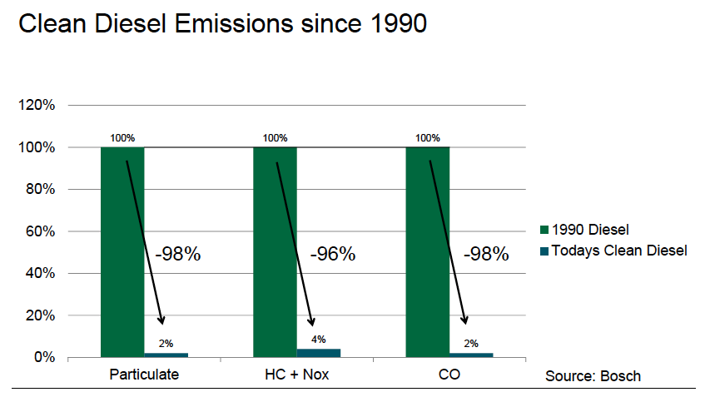

CO2 Calculations.

If one-third of all Americans switched to Diesel vehicles, about 1.4 million barrels of oil would be saved. From each barrel, 19 gallons of motor gas is created.9 From each gallon of gas, 20 pounds of CO2 are emitted.10 That means saving about 1.4 million barrels of oil is equivalent to about 532 million pounds of CO2 that would not be emitted from motor gas. Since trees absorb CO2, it would require the planting of about 600,000 trees each day to absorb the extra 532 million pounds of CO2 emitted by gasoline-powered engines.11

7 <http://www.volkswagenag.com/content/vwcorp/info_center/en/news/2011/05/Clean_Diesel_USA.htm>

8 <http://www.dieselforum.org/news/importance-of-clean-diesel-technology-to-reduce-greenhouse-gases-highlighted-at-global-climate-and-clean-air-event-in-sweden>

9 <http://www.mathesongas.com/industrialgas/pdfs/bulk-carbon-dioxide.pdf>

10 <http://205.254.135.7/tools/faqs/faq.cfm?id=24&t=10>

11 <http://www.geoecs.com/>

**Our Partners:**

In 2009 (VW’s Jetta TDI®) and 2010 (Audi’s A3 TDI®) Clean Diesel models won the renowned “Green Car of the Year” award (the BMW 335d, the VW Golf TDI® and the VW Passat TDI® were among the top five finalists).

Sales of clean diesel passenger cars rose by 36 percent in 2011.

**Additional Sources:**

<http://www.cleandieseldelivers.com/>

<http://www.dieselforum.org/>

**Share Copy:**

Facebook and Google+ Share Copy:

**Clean Diesel. Clearly Better.**

This is not your grandfather’s diesel. No way. Clean Diesel technology has changed everything. Learn how it can help improve your driving experience — and help you stop fewer times at the pump.

Twitter Share Copy:

**Clean Diesel. Clearly Better. Clearlybetterdiesel.org.**